**I S 300 Project**

**Blood Bag Storage**

**Group 5**

|  |  |
| --- | --- |
| Matthew Edgar | Paloma Aguado |
| Max Seirsen | Edmundo Briones |
| Ella Palacio | Grant Gage |
| Jonathan Tran | Mick Landtow |

For Professor Bazarah’s I S 300 Class (32160

Fall 2019

**Introduction**

Something that goes unnoticed in our daily lives is blood donation. One only thinks of blood donations when the truck roles up to campus, and usually it ends there. But blood donation is something popular and something highly needed that evades everyone's radar. Consequently, every two seconds someone in the U.S. needs blood. But only 3% of eligible donors actually donate. Once someone donates red blood cells it must be used within 42 days, and platelets must be used within 5 days. Furthermore, some studies have even showed that blood stored for more than 14 days can have adverse effects on the patient. So blood donations is something overlooked, but highly and frequently needed in today’s climate. Sadly, it does not end there, a majority of blood donated is actually thrown out as medical waste, either it doesn’t match the patient or that blood just expires.

**The Problem**

The Red Cross had an issue. Their administration, as well as the doctors and nurses of hospitals they supply, had a hard time tracking the numerous blood bags stored at hospitals. Doctors and Nurses would write the blood type and donor information on labels attached to each bag, but that made it difficult to quickly determine how much blood of each type was on hand and usable to help patients.

**Solution**

We created a database that organizes the information pertaining to each blood bag so the Red Crosscan keep track of detailed records about the donors, hospitals and patients. We use four tables to catalog information regarding blood bags, donors, hospitals, and patients. Having “BagID”, “DonorID”, “HospitalID” and “PatientID” as primary keys for each table simplifies the process of pulling up information on each entity. After using our database to check for blood bags of a certain type, hospitals can then contact other hospitals where blood bags of that specific type are kept in inventory. A BagID would be assigned to a patient and hospital staff would be able to find more information on the blood bag by simply looking up the BagID on our database. We facilitated the process of accessing more information regarding each blood bag by creating a query that links Bag ID with the donor’s blood type, first and last name, and any important medical history. We also created a query which links Donor ID with donation information and information about the hospital that received the blood bag. This helps hospitals keep track of when the blood was drawn, how much blood was drawn, and which hospital received the blood. Not only did we create queries to facilitate keeping track of current blood inventory, but we created a query that links Patient ID with the patient’s information, the donor’s name and information on the hospitals. This helps hospitals keep track of previous blood transfusions and keep a detailed history on which donors the patients received blood from and in which hospital the blood transfusions took place. In order for hospitals to keep track of and access data on current patients and possible recipients of blood we created a query that links Patient ID with patient information and condition to determine which patients have priority. Finally, we created four reports with information on donors, hospital blood bag inventory, hospitals, and patients to make it easier for hospital staff to pull up any immediate information they might need in the case of a blood transfusion. With the help of the reports, hospitals can easily determine which patients are in need of blood transfusions, which hospitals have the blood they need, how to contact the hospitals, and if necessary, how to contact the donors.

**The Outcomes**

*Queries*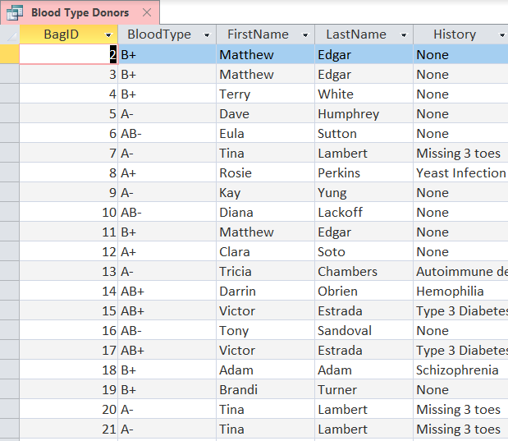

The Blood Type Donors query finds all accounted for blood bags, shows their blood type, who donated it, and the donors history. This will allow users to determine what types of blood is on hand at any given time.

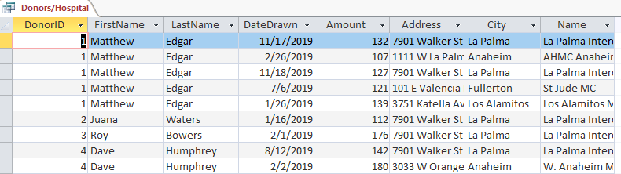

The Donors/Hospital query shows the names and dates of different donations, and shows which hospital each donation was sent to. Users can use this query to determine who is donating blood frequently, and might need to slow down.

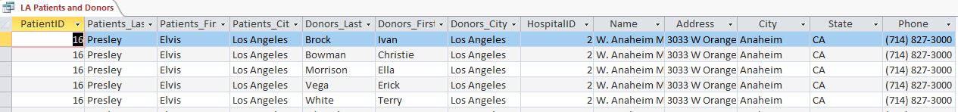

The LA Patients and Donors query shows each blood donation that was sent to specific hospitals. Users can use this query to match Patients with Donors near them, and hopefully find a blood type match.

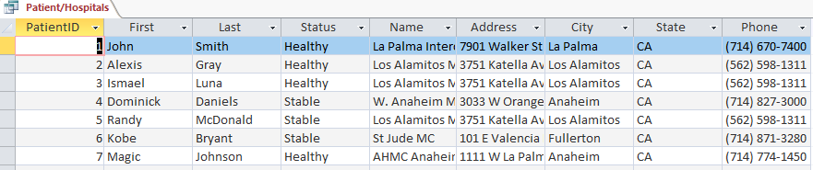

The Patient/Hospitals query shows each patient currently in the system, and the hospital they are staying in. Users can use this to determine how many patients are at each hospital, and which hospital needs blood urgently.

*Reports 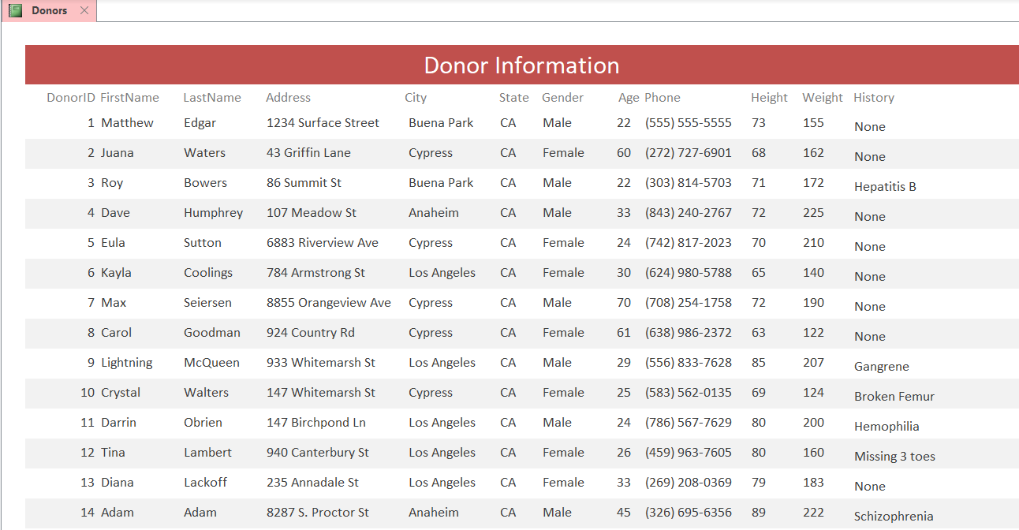*

The Donors report shows the information of each donor in a pleasant format. Users can use this to determine the info of each donor quickly and easily.

*Forms*

Each form shows the information stored in each respective table to the user, one record at a time. It is by far the easiest and fastest way to view individual records one at a time. The forms used for this project are, Blood Bags, Donors, Hospitals, and Patients. 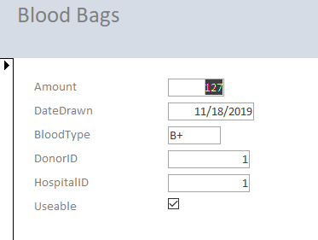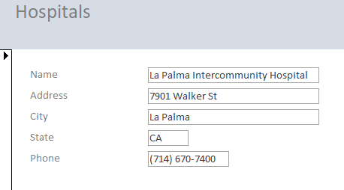

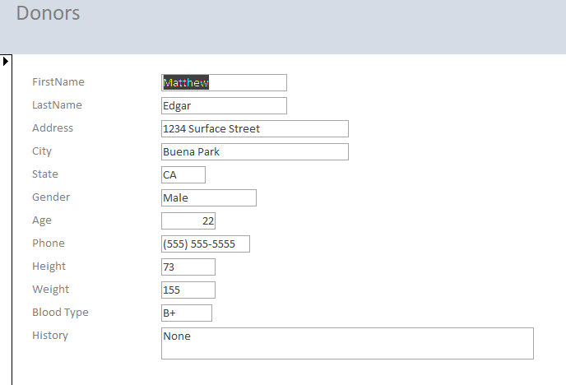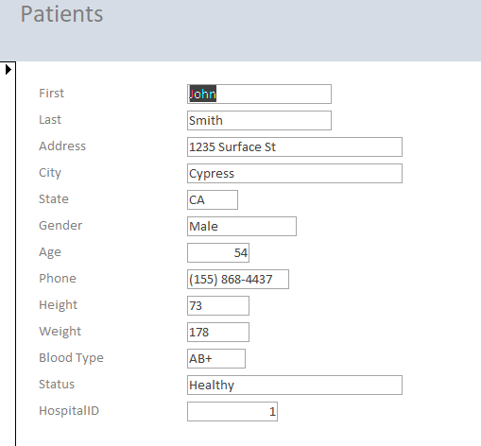

**Challenges Faced**

During the course of the project our team faced multiple difficulties that we worked through using communication and teamwork. The first of such difficulties arose when it came to choosing a problem to tackle using the database. It took a week or so to sift through many potential ideas which finally resulted in our blood donation database. The next challenge came with the delegation of tasks that each team member would complete. To figure this out, we came together and assessed the expertise of each teammate in order to find who would be best suited for each task required to complete the project. The other problems we came across had to do with the Access database itself and the data inputs required for it to function correctly. Some issues occurred when it came to finding usable data, namely because hospital records are usually kept confidential between patients and doctors, and not typically publicly available. To get past this, we simply used the names/health information of famous people along with inputting made-up names/health information. We also had the same problem when it came to finding blood types, so a python script was used to randomly generate blood types for each of the “patients” and donors. During the project, we also faced some of the pitfalls of using Access (because no application is perfect for every user). One place where it caused some difficulties was when it came to collaborating on the file. Unfortunately, Access does not support multiple users working on/editing the database simultaneously so we were forced to coordinate when different teammates could get on the database and work. This was made a bit easier by sharing the file through Google Drive and some careful coordination. Another challenge Access provided came when creating the formatting for the reports. Some of the reports included many data types that stretched past the borders of a single page. This required some inventive thinking in order to fit everything on to said reports while also having them remain readable. There weren't too many issues creating the reports, except with formatting. Some of the reports had a lot of data types that go beyond the borders of a single page, so I had to figure out how to fit everything while still making it readable.